WEEK-4 PRACTICAL
Task 1: Write a C program where a parent process creates multiple child processes and synchronizes their completion using wait() and waitpid(). Compare the behavior of both functions.
CODE:
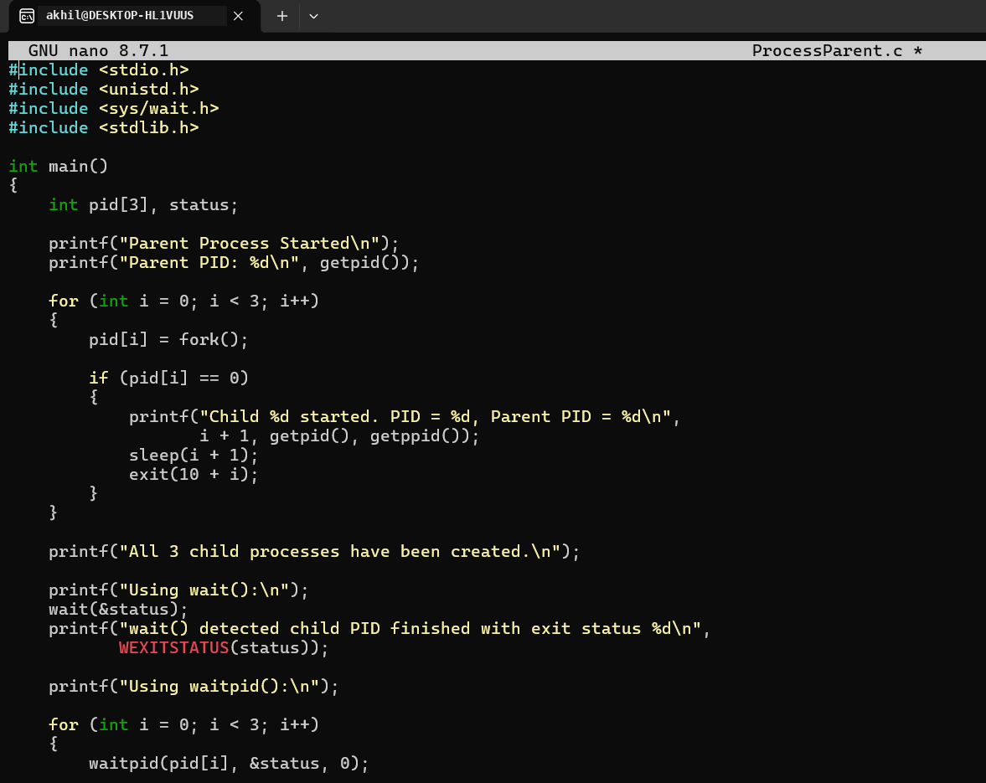
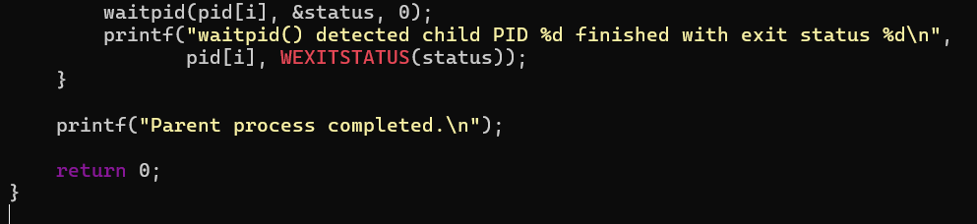

OUTPUT:
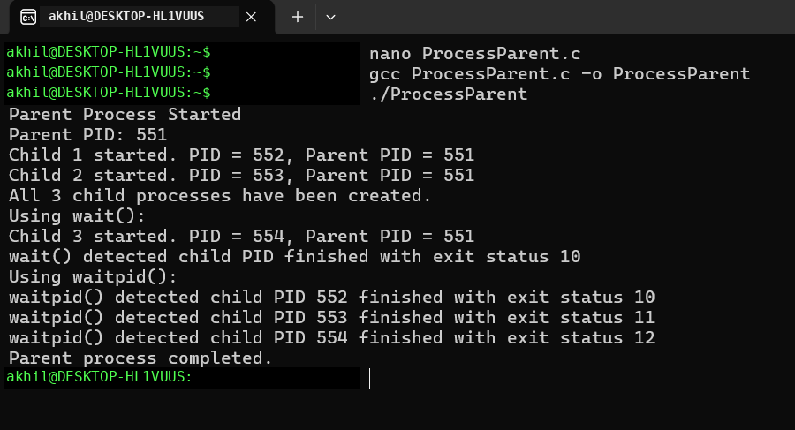
REPORT: The Multiple child processes were created successfully and their completion was synchronized using wait() and waitpid().
Task 2: Create a scenario where a child process becomes a zombie process. Investigate the process table and then modify the program to eliminate zombie processes using proper synchronization techniques.
CODE:
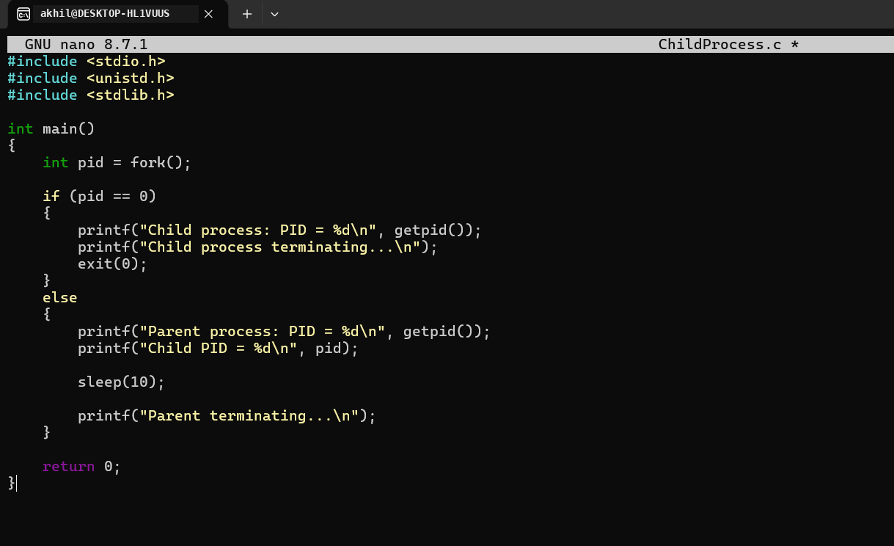
OUTPUT:
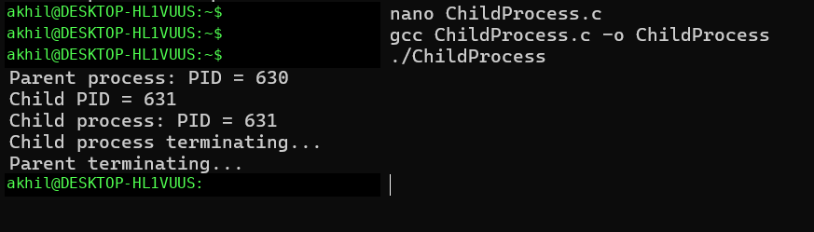
REPORT: The zombie process was successfully observed, and using wait() in the parent process prevented the child from remaining as a zombie.
PS -EL:
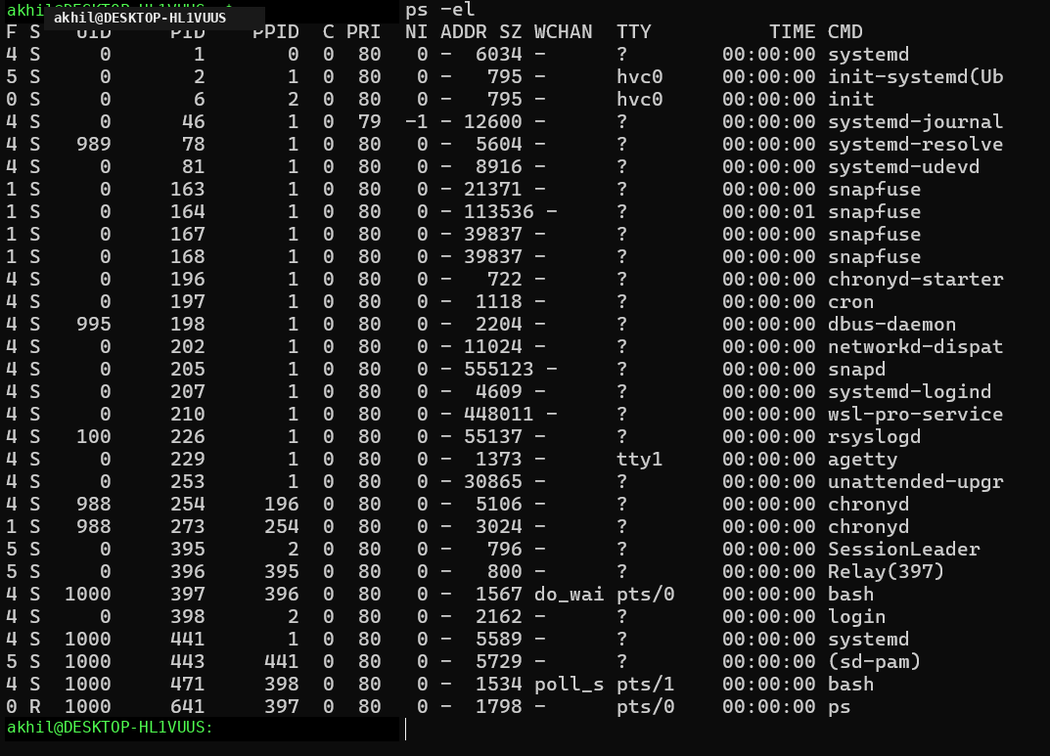
REPORT: The process table was successfully observed using ps -el, and the zombie process was identified by the Z state.

